**Ganpat University**

**Faculty of Engineering & Technology**

**Computer Science & Engineering**

**(2CSE204) Basics of Operating System and Shell Scripting**

***Name:- Dwij Vatsal Desai***

***Sem:- 2***

***Sub: - BOSS***

***Enrollment No.:- 23162121027***

***Prac:- 5***

***Date:- 27/3/2024***

**Practical 6**

1. Create a user with ***yourname_surname*** with some password and lock the account so that the user should not be able to login.

***Command:-***

sudo useradd Dwij_desai

sudo passwd Dwij_desai

password:- Hellooworld

***Screenshot:-***

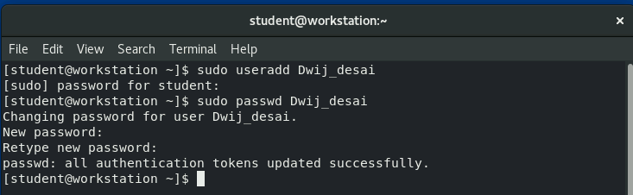

1. Unlock the the user and now the user should be able to login

***Command:-***

sudo usermod -L Dwij_desai

sudo usermod -U Dwij_desai

Su – Dwij_desai

***Screenshot:-***

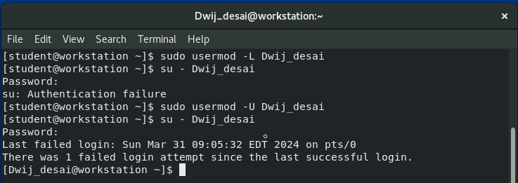

1. Set the password policy of the user in such a way that he needs to change password on next login.

***Command:-***

sudo chage -d 0 Dwij_desai

***Screenshot:-***

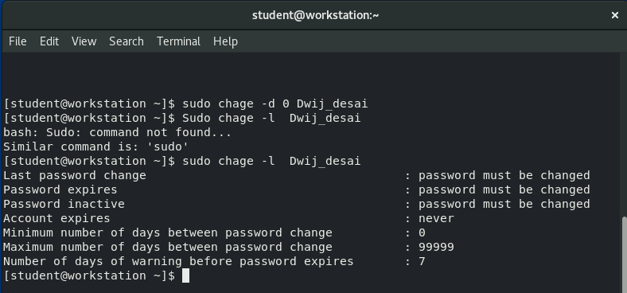

1. Change the password policy for the user to require a new password every 90 days with a warning period of 10 days and an inactive period of 15 days.

***Command:-***

Sudo chage -M 90 -W 10 -I 15 Dwij_desai

***Screenshot:-***

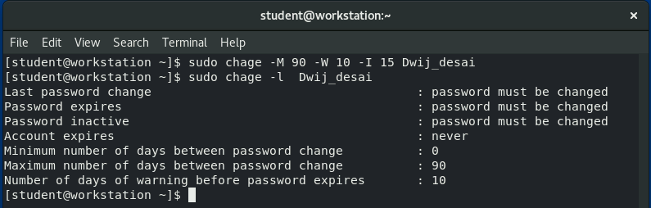

1. User’s account must expire after 180 days from the date of user creation

***Command:-***

sudo chage -E $(date -d “+180 days” +%Y-%m-%d) Dwij_desai

***Screenshot:-***

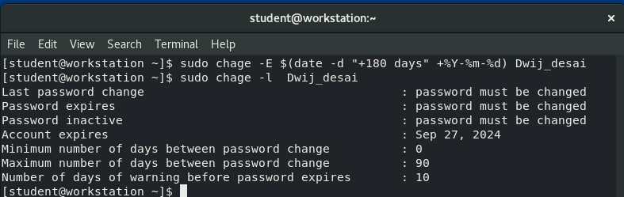

1. Verify the password policy

***Command:-***

sudo chage -l Dwij_desai

***Screenshot:-***

